|  |  |  |
| --- | --- | --- |
|  | Available online at www.sciencedirect.com    AASRI Procedia 3 ( 2012 ) 589 – 594 |  |
| 20 012 AASRI Conference e on Model ling, Identif fication and d Control | |

Design n and DS SP Optim mization of Real--time Mu ulti-Cam mera

Tracki ing

Xiao Yana,* *, Junchuan n Yangb, B Bo Yaoc

*aSch hool of Informatio on Science and En ngineering, Yunn nan University,*

|  |  |  |  |  |  |
| --- | --- | --- | --- | --- | --- |
| *No o.2, Chestwood N North Road, Kunm ming, Yunnan, Ch hina, 650091*  *bD Department of Co omputer Science, University Colle ege London*  *Gower Stree et, London,United d Kingdom,WC1E E 6BT* | | | | | |
| *cSchool o of Computer Scie* | | | | *nce and Electron nic Engineering, U University of Esse ex* | |
| *Wivenhoe Park k, Colchester, Un nited Kingdom,CO O4 3SQ* | | | | | |
| **Abst tract**  In re ecent years the ere is a domina anttrend toward ds the deploym mentof advance ed visual analy ysisalgorithms o on embedded  platf forms. However r, this deploym ment is very cha allenging as em mbedded system ms usually affor rd limited resou urces such as  calcu ulating perform mance,memory a and power. The erefore, to addr ess this problem m, In this paper r we introduces s anoptimized | | | | | |
| multi i-camera tracki ing system base ed on multiple | | | | TI DSP TMS3 320DM6446for r trackingobject ts across multip ple embedded | |
| smar rt cameras whic ch embedsintel lligent processo ors. Firstly, the e overlapping a areas and homo ography projec ction relations | | | | | |
| betw ween adjacent ca ameras' field of f view is calcula ated. Based on t the relations of f cameras view | | | | | obtained and tr racked data of |
| each | single camera, a homography | | based target ha andover procedu ure is done for long-term mult ti-camera tracki ing.After that, | | |
| we fu fully implement ted the tracking g system on the | | | | embedded sma art cameras dev veloped by our | group.Finally, t to combat the |
| huge e computational l complexity, a | | | novel hierarch hical optimizati on method is p proposed. Exper rimental results s demonstrate | | |
| the r robustness and | | real-time effic ciency in dynam mic real-life en nvironments an d the computat tionalburden is s significantly | | | |
| optim mized by 98.84% % which is low w enough for fur rther biometrics s tasks such as r recognition.  © 20© 2012 The Authors. Published by Elsevier B.V. .Published by Open access under [CC BY-NC-ND license.](http://creativecommons.org/licenses/by-nc-nd/3.0/) El[sevier B.V .](http://creativecommons.org/licenses/by-nc-nd/3.0/)  Sele Selection and/or peer review under responsibility of American Applied Science Research Institute ection and/or p peer review un nder responsib bility of Amer rican Applied Science Rese earch Institute  *X Xiao Yan. Tel.: + +0-86-180829589 972. | | | | | |

*E-mail address:*xx xiaoyen@gmail.co om.

2212-6716 © 2012 The Authors. Published by Elsevier B.V. Open access under [CC BY-NC-ND license.](http://creativecommons.org/licenses/by-nc-nd/3.0/)

Selection and/or peer review under responsibility of American Applied Science Research Institute

doi: 10.1016/j.aasri.2012.11.093

590  *Xiao Yan et al. / AASRI Procedia 3 ( 2012 ) 589 – 594*

*Keywords:*Embedded systems, distributed smart cameras, visual tracking

**1. Introduction**

Together with the increasing population density in metropolitan cities, the demand for maintainingsecurity of citizens is increasing. In alignment with this demand, the smart Closed Circuit Television system(CCTV) surveillance[1] isbecoming pervasive. Hence, automated surveillance has become an emerging technology since the lastfew years.The task of automated surveillance for public locations, which are usually crowded and wide-area, such as public transport stations usingindependent smart cameras [2] almost impossible due to the limitation of cameras’ field of view and the heavytarget occlusion [3]. Hence, scene surveillance using a cooperative multi-camera network [4] isbecoming the preferred solution for surveillance camera users, as will not require major hardwareupgrade. Therefore, a multi-camera tracking method is introduced in this paper, which has been completely implemented on our embedded smart cameras and testedon traffic surveillancenear our campus. Nevertheless, due to the computing limitation of the processing unit in each smart camera, advanced video processing algorithms which are usually of high computational complexity, cannot be performed without optimization. Consequently, in this paper, anovel hierarchicaloptimizationparadigm with several practical techniques for commonoptimization is presented. According to our experiment results, the overall performance is remarkably boosted using our proposed optimization methods.

The rest of this paper is organized as follows. In section 2, we provide the proposedmulti-camera tracking system. Section 3 presents the proposed hierarchicaloptimization methodology. Section 4 presents the experiments and results and finally the conclusions are presented in section 5.

**2. The proposedmulti-camera tracking system**

To cooperatively track and monitor movingtargets in large-scale area, multiple overlapping cameras are utilized to observerwide surveillance scenes fromdifferent views.Firstly, in the initial stage of our system, multi-camera calibration is done to gain the image plane correspondence relationshipbetween the adjacent cameras byhomography transformation [5] for target hand-off. After that, multi-objects tracking is performed continuously in each single smart camera which is shown in Fig. 1 (a) to obtain the surveillance information of the moving targets based on which object hand-off is carried out for multi-camera tracking shown in Fig. 1 (b).

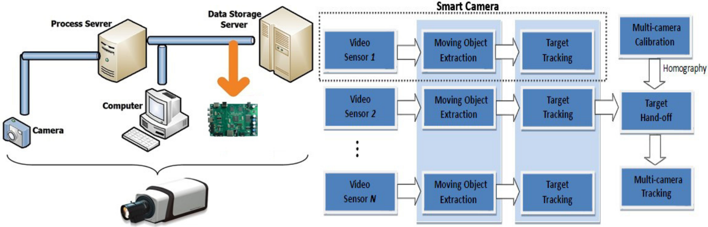

(a) (b)

Fig. 1 Structure block diagrams (a) Integratedsmart camera; (b) Overall system structure.

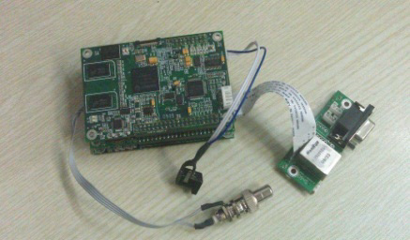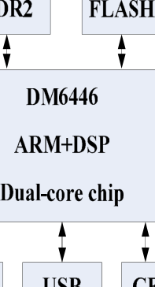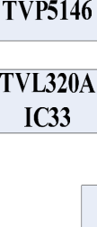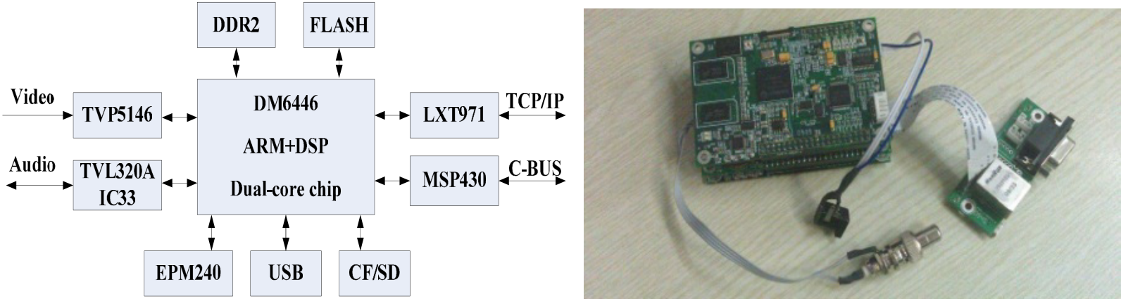

*Xiao Yan et al. / AASRI Procedia 3 ( 2012 ) 589 – 594*  591

The entire embedded system is divided into three components described in the block diagram above. Firstly, a CCD color sensor providing NTSC or PAL video is used for capturing raw video data. Then, the embedded video analysis agent is designed by employing a DaVinciTMS320DM6446 [8] dual-core device with an ARM9 and C64+ DSP. Fig. 2 displays the hardware architecture of embedded video agent designed in this paper. And Fig. 3 shows the highly integrated 3-level embedded system developed by our research group.

Fig. 2 Hardware ArchitectureFig. 3Our 3-level EmbeddedVideo Agent

*2.1Single-camera tracking*

In multi-camera network surveillance, single-camera tracking is the fundamental module to obtain the information of the moving targets such as position, motion trajectory, shape, etc. Therefore, in our system, we utilized the tracking paradigm in [5]. Specifically, Gaussian Mixture Models (GMM) is employed to compute the background images of the surveillance scenes. Then, foreground objects (Blob) extraction is done to gain the bounding boxes and centroids of the moving targets. Finally, object tracking is performed based on Mean-shift and Kalman filter to analyze the motion history and trajectories.

*2.2 Multi-camera tracking*

|  |  |  |  |  |  |  |  |  |  |  |  |  |  |
| --- | --- | --- | --- | --- | --- | --- | --- | --- | --- | --- | --- | --- | --- |
| When | moving | objectsenter | | the | | overlapping | | areabetween | adjacent | cameras, | | ground | plane |
| homographymappingis | | | employed | | tocreate | | the | viewpoint | correspondence | | bymapping | | and |

matchingtargetcentroid positions between neighboring cameras, which is defined as follows:

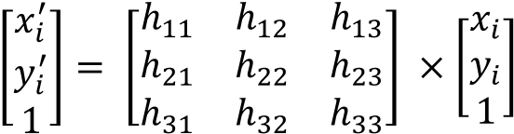 (1)

Where*H(h11~h33*) denotes*3**3*homography matrix describing the projection relationship of the two cameraswhile () and  represent the correspondingcentroids of the moving targets in eachcamera.

To calculate the homography matrix, in the initial stage of our system, we extract four best pairs of feature points from background images ofthe two surveillance scenes by using ASIFT [] which is robust in dynamic real-life environments. Finally, based on the feature points, L-M(Levenberg-Marquardt) [] is performed to compute the homographywith Projection Error (PE) minimization equation defined as follows:

 (2)

592  *Xiao Yan et al. / AASRI Procedia 3 ( 2012 ) 589 – 594*

Then, based on the homography, target hand-off is done by examining *PE* between the centroid of two target

|  |  |  |  |  |
| --- | --- | --- | --- | --- |
| candidates. If |  | , where |  | is a parameter which can be dynamically set,then the two |

candidatesarecorrespondingtargets and marked the bounding box and trajectory in a unique color, shown in Fig. 4.

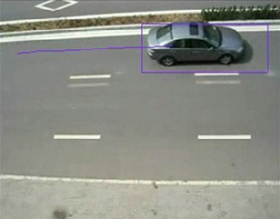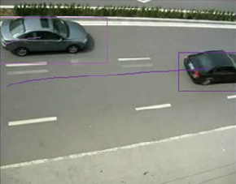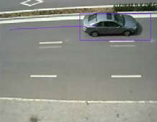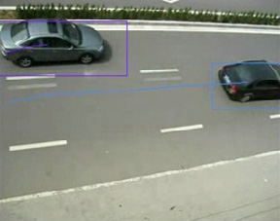

(a) (b) (c) (d)

Fig. 4 Target hand-off for multiple camera tracking, (a)(b) before corresponding; (c)(d) after corresponding.

**3. DSP performance optimization**

To achieve the real time performance of the embedded DSP system, in this paper, a hierarchical optimization method is proposed based on DM6446 are used. According to the performance evaluation done by Code Composer Studio (CCS)profiling module, main performance bottlenecks are found, which areGaussian Mixture Model(GMM) for background reconstruction and moving object(Blob) extraction, respectively.Therefore, the proposed hierarchical optimization method isprimarilyconcentrated in these two modulesusing project-level optimization, algorithm-level optimization and code-level optimization.

*3.1Project-level optimization*

To maximize C/C++ compiler performance, the DSP code can be optimized comprehensively by using proper compiler setting [6]. Firstly, software pipelining is used to schedule instructions in a loop so that multiple instructions of the loop are executed in parallel. In C6000 compiler, we use “*-o2*” and “*-o3*” compiler options to arrange software pipelines for the codes automatically. Then, “*-pm*”, “*-mt*” and “*-op3*”compiler settings are employed in our compiler to reduce theperformance costin loop iterations. Additionally,to boost the efficiency,in the proposed system, the data which is frequently visited and processed are stored in internal DSP memory and important functions and procedures are executed in CACHE which is supreme fast memory.

*3.2 Algorithm-level optimization*

Since the detailed information of moving target such as texture, shape, etc. is not significantly essential for GMM and blob extraction, therefore before these two procedures, input video signal can be down-sampled to a smaller resolution for computational complexity reduction. So in our system, we resized the input video

|  |  |  |
| --- | --- | --- |
| from D1 (*720* | *576*) to CIF (*360* | *288*) using resizer module in Video Processing Subsystem (VPSS) which |

is a standalone peripheral device on DM6446 for resizing video without any computational cost in DSP. Then, the resized video is analysed by GMM and blob extraction to obtain the positions and bounding boxes of the moving objects. After that, the gainedpositions arere-mapped to D1 coordinate for the on-going procedures such as tracking, classification and recognition. Furthermore, for the purpose of better pipelining the algorithm to achieve higher performance, we divide the GMM function into three stages include backgroundmodel initialization, updatingand comparison, and performed separately. According to the profiling, the performance is greatly enhanced because the software pipeline is generated successfully.

*Xiao Yan et al. / AASRI Procedia 3 ( 2012 ) 589 – 594*  593

*3.3Code-level optimization*

Generally, the generation of software pipeline isakey stepforcode-leveloptimization.However, there are several common situations hinder producing software pipelines, i.e., loops nesting, in-loop function calling, jump instructionsetc. Therefore, we examined and divided large loops into small loops to increases instruction-level parallelism guaranteeing the effective creation of software pipeline by using the instruction “*MUST_ITERATE*” in oursystem. After that, as the pixel value is *8-bit* length, to further improve the quality of the software pipeline, we utilized data packing techniques to pack and parallel process multiple pixels in one *32-bit* pack by executing the packing and unpacking instructions such as “*_memd8_const”, “_packl4”, “_hi”, “_lo”, “_subabs4”, “_cmpgtu4”, “_itoll”*, etc.

By utilizingour proposed hierarchicaloptimization method, the system performance is increased significantly as described in the Table 1.Since the performance of DSP core is at a clock rate of *810* MHz (*810* million clock cycles per second), the overall computational budget is reduced by *98.84%* and the system performance is boosted from *2.03* frames/second to *30* frames/second reaching the maximum frame rate.

Table 1.System performance comparison by using our proposed hierarchicaloptimization method

|  |  |  |  |  |
| --- | --- | --- | --- | --- |
| **Module Name** | **Before Optimization** | | **After Optimization** | **Optimization Ratio** |
| clock cyclesframes/s | | clock cycles frames/s | clock cycles |
| GMM Background | 379672557 | 2.13 f/s | 338754830 f/s | 99.11% |
| Reconstruction |
| 19218288 | 30 f/s | 124931230 f/s | 93.49% |
| Moving Object |
| (Blob) Extraction |
| 398890845 | 2.03 f/s | 463686030 f/s | 98.84% |
| Overall |
| Performance |

**4.Experiments and results**

To demonstrate the robustness and effectiveness of our proposed system,we have built a test-bed environment around our campus by deploying multipledistributed cameras and performedseveral real-world experiments in various environments. As shown in Fig. 5 (a) (b) (c) (d), the images demonstrate two result set of ourmulti-camera trackingsystem in anoutdoor scene. Fig. 5 (a) (c) are the snapshots from the left camera view, whileFig. 5 (b) (d) are from the right camera view. Specifically, real-time multiple objects tracking is perform continuously on each individual camera to analyze the trajectories and bounding boxes of the moving targets, as displayed in Fig.5, each surveillance target is tracked successfully and marked with bounding box and trajectory in uniquecolor to distinguish from others. After that, once moving targets enter the overlapping area between two adjacent cameras, object hand-off procedure is carried out to compute the accordance relationships of the targets in the overlapping area for multi-camera long-term tracking. As depicted in Fig.5, targets in the overlapping area are successfully tracked and hand-off and marked in their unique tracking color.

|  |  |  |  |
| --- | --- | --- | --- |
|  |  |  |  |

(a) (b) (c) (d) Fig. 5 Experiment results for dual camera-tracking in an outdoor environment around our campus

594  *Xiao Yan et al. / AASRI Procedia 3 ( 2012 ) 589 – 594*

In Fig. 6, experiments results in general view are shown. As can be seen in Fig. 6 (a), raw video is captured by our 3-level embedded video analysis agent from the video input device, and then our multi-camera tracking algorithm is carried out to process the video data in real-time performance, and finally, tracking results are displayed directly intwo standalone screens as shown in the Fig. 6 (b).

|  |  |
| --- | --- |
|  |  |

(a) (b)

Fig. 6 Snapshot of our experiment devices and results in general view

Full demo video for our proposed embedded multi-camera tracking system is provided [9] on YouTube.

**5.Conclusions**

In this paper, we represented the multi-camera tracking algorithm and implemented on the embedded platformTI dual-core TMS320DM6446 (ARM+DSP). In our proposed system, a traditional tracking paradigm for singlecamera tracking based on GMM, Mean-shift and Kalman filter is utilized to detect and track multiple targets. Then, when the surveillance objects enter the overlapping area between adjacent cameras, a homography based target hand-off procedure is perform for long-term multi-camera tracking. However, the computation complexity for multi-camera system is huge especially for embedded processor based system. Therefore, to conquer the challenging problems in low-cost, reliable and efficient way, we designed embedded integrated smart camera by utilizing the hardware structure of TI TMS320DM6446 based on which our proposed multi-camera tracking algorithm is implemented, and optimized reaching real-time performance by our proposedhierarchical optimization method. The overall experimental results have fully verified the effectiveness and robustness of our proposed algorithm and the stability of the embedded platform.

**References**

[1]R. Kleihorst, B. Schueler, A. Danilin, Architecture and applications of wireless smart cameras(networks), in: Proceedings of the IEEE International Conference on Acoustics, Speech, andSignal Processing, 2007.

[2]B. Rinner, W. Wolf, Introduction to distributed smart cameras, in: Proceedings of the IEEE96 (10). [3]W. Hu, T. Tan, L. Wang, S. Maybank, A Survey on Visual Surveillance of Object Motion andBehaviors, in: IEEE Transactions Systems, Man and Cybernetics 34 (2004) 334–352.

[4]R.T. Collins, A.J. Lipton, H. Fujiyoshi, T. Kanade, Algorithms for cooperative multi-sensorsurveillance, in: Proceedings of the IEEE, 89 (2001) 1456–1477.

[5]H. Aghajan and A. Cavallaro, Multi-camera Networks: principles andapplications. USA: Elsevier, 2009. [6]Texas Instruments, Davinci-DM644x Evaluation Module technical reference”, March, 2006.

[7]Morel, J., Yu, G.: Is SIFT scale invariant? Inverse Problems and Imaging 5(1), 115–136 (2011).

[8]M.I.A. Lourakis, A brief description of the Levenberg-Marquardt algorithm implemented bylevmar.

[9]http://youtu.be/pyKzigK30bM